
Cotswold Coaching by Jez
Wiltshire & Gloucestershire
01285 238322
info@cotswoldcoaching.co.uk

Primary School TRI GOLF @ Leckhampton School

Parents of Children in Years 3,4,5,6
Cotswold Coaching by Jez provides fun and exciting GOLF lessons. Teaching technique, discipline and coordination whilst playing a huge variety of team and individual games.

After School GOLF Club

GOLF Club will be run by Jez, a golf instructor with over 20 years’ experience, and will continue for 4 weeks.
It will take place every MONDAY afternoon from 3.20pm till 4.20pm on the school MUGA or classroom.
The dates will be as follows: -

13th APR * 20th APR * 11th MAY 18th MAY
*Please note, no lesson 27th APR and 4th MAY (bank holiday)

The total cost for the term’s 4 sessions is £24.00 and will include all necessary equipment and lots of fun!

How to reserve space:
So not to burden the school with extra admin we will be taking bookings direct for the club.
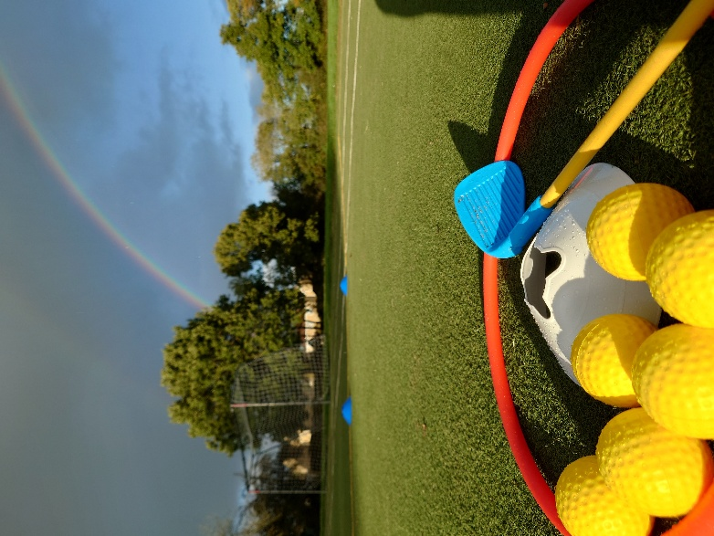
Online: www.cotswoldcoaching.co.uk
Visit the link above and submit a form with your Childs details and your contact information.

Send us an email with the following:
Pupil’s Name | Year Group | Parent’s Name | Contact
Telephone Number | Email Address

How to Pay:
- Internet Banking transfer: Account Name: Cotswold Coaching by Jez
Account Number: 73072363 Sort Code: 20-68-15
- Cash: Please give to your child in sealed envelope to the first lesson.
Should you have any queries, please contact me directly.
01285 238322 or hit the Whatsapp button on my home page.
Meeting classroom (ROWAN).

