
Cotswold Coaching by Jez
Wiltshire & Gloucestershire
07884065195
info@cotswoldcoaching.co.uk

Primary School Archery- Leckhampton School

Parents of Children in Years 2,3,4,5,6
Cotswold Coaching by Jez provides fun and exciting archery lessons. Teaching technique, discipline and coordination whilst playing a huge variety of team and individual games.

After School Archery Club
Archery Club will be run by Jez, an Archery GB Qualified instructor, and will run for 10 weeks. It will take place every MONDAY afternoon from 3.20pm till 4.20pm on the School playground, field or school hall. The dates will be as follows: -

5th JAN 12th JAN 19th JAN 26th JAN 2nd FEB 9th FEB
23rd FEB 2nd MAR 16th MAR 23rd MAR

The total cost for the term’s 10 sessions is £60.00 and will include all necessary equipment and lots of fun!

How to reserve space:
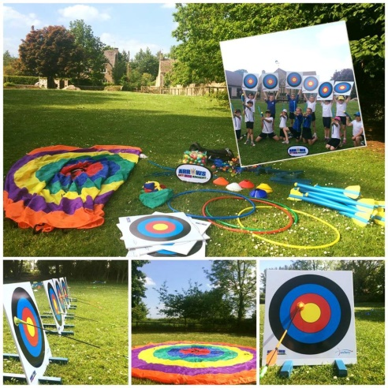
So not to burden the school with extra admin we will be taking bookings direct for the club.

Online: www.cotswoldcoaching.co.uk
Visit the link above and submit a form with your Childs details and your contact information.

Telephone/text/whatsapp: 07884065195
Give us a call; if we are instructing and can’t pick up, please try a text message and we will contact you as soon as possible.

Send us an email with the following:
Pupil’s Name | Year Group | Parent’s Name | Contact
Telephone Number | Email Address

How to Pay:
- Internet Banking: Account Name: Cotswold Coaching by Jez Account Number: 73072363 Sort Code: 20-68-15
- Cash: Please give to your child in sealed envelope to the first lesson.
Should you have any queries, please contact me directly.
