

Cotswold Coaching by Jez

Wiltshire & Gloucestershire

07884065195

jez@cotswoldcoachingbyjez.com

Primary School Archery- Leckhampton School

**Parents of Children in Years 2,3,4,5,6**

Cotswold Coaching by Jez provides fun and exciting archery lessons. Teaching technique, discipline and coordination whilst playing a huge variety of team and individual games.

**After School Archery Club**

Archery Club will be run by Jez, an Archery GB Qualified instructor, and will run for 6 weeks. It will take place every MONDAY afternoon from 3.20pm till 4.20pm on the School playground, field or school hall. The dates will be as follows: -

**24th FEB 3rd MAR 10th MAR 24th MAR 31st MAR 7th APR**

The total cost for the term’s 6 sessions is £36.00 and will include all necessary equipment and lots of fun!

**How to reserve space:**

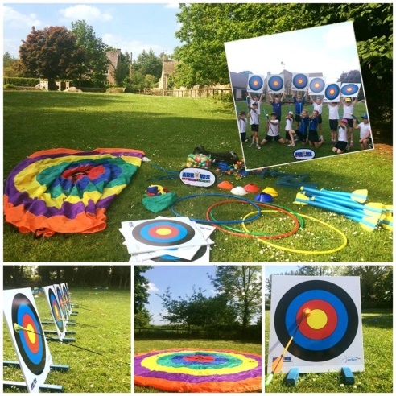So not to burden the school with extra admin we will be taking bookings direct for the club.

**Online:** www.cotswoldcoaching.co.uk

Visit the link above and submit a form with your Childs details and your contact information.

**Telephone:** 07884065195

Give us a call; if we are instructing and can’t pick up, please leave a message and we will contact you as soon as we are back in the office.

**Send us an email** with the following:

Pupil’s Name | Year Group | Parent’s Name | Contact

Telephone Number | Email Address

**How to Pay:**

* Internet Banking: Account Name: Cotswold Coaching by Jez Account Number: 73072363 Sort Code: 20-68-15
* Cash: Please give to your child in sealed envelope to the first lesson.
* Cheque: Made payable to Cotswold Coaching by Jez. Please give to your child in sealed envelope to the first lesson.

Should you have any queries, please contact me directly.

