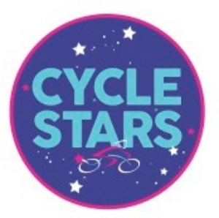

Leckhampton Primary School
Cycling - 2025

Welcome back to a new term of cycling at Leckhampton School, we hope you’ve all enjoyed your Christmas break. I’m sure that some children have been lucky enough to get a new bike for Christmas and is eager to get cycling.
I thought this would be a good opportunity to give more information regarding cycling at Leckhampton School; Many of the children attending have been returning term after term. I’m sure they don’t mind me saying, but their cycling skills were pretty rubbish to begin with and they found cycling on grass difficult.
However, our riders have improved tremendously and Leckhampton has become successful in winning two inter school cycle races.
During the last term riders got the opportunity to try out the professional cycle racing track at Evesham Velopark, where we hope to host an event in the spring.
Cycle Racing is what we coach every Tuesday after school 3.20 to 4.20pm. This will include checking bikes to see they are in good working order, riding in and out of the saddle, awareness of riders around them, cornering fast and making good use of their gears.
We are starting back on Tuesday 14th for a 11 week spring term *Please note there is no session on the 18th March (Parents evening)
This is a popular group that gets full quickly, no experience is necessary, all we ask is that children participate and listen to instruction. Children need to be able to ride unaided and have a bike in good working order and a correctly fitting helmet.
Term fee £66 *concessions available see terms & conditions
Please email Steve at cyclestars001@gmail.com if you are interested in joining.
Cycle Stars is an all-inclusive youth Cycling Club promoting ‘sponsor a child’ scheme.

